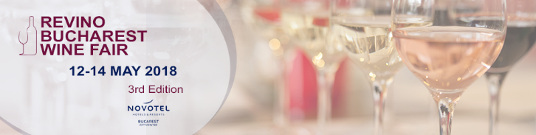

CrameRomania.ro and ReVino.ro look forward to welcoming you to the third annual ReVino Bucharest Wine Fair, from May 12-14, hosted at the same elegant venue, Novotel Hotel, Paris Hall, Le Foyer, Calea Victoriei, 37B, Bucharest.

The event continues its mission to promote quality Romanian wines, small and medium-sized wineries, responsible consumption, and local wine tourism. During the event you will be able to taste over 230 premium wines from 35 exhibitors, meet the people who produce them and hear the stories of the vineyards they come from.

Exhibitors:

- 7ARTS
- Crama Alira
- Amfiteatru Vitis
- Crama Aramic
- Crama Aurelia Visinescu
- Crama Avincis
- Crama Balla Geza
- Crama Basilescu
- Crama Bauer
- Crama Budureasca
- Domeniul Bogdan
- Crama Carastelec
- Crama Cepari
- Crama Corcova Roy & Damboviceanu
- Casa de Vinuri Cotnari
- Domeniul Dragasi
- Halewood Wine & Spirits
- Crama Histria
- Le Manoir - Vinuri & Accesorii
- Crama La Salina
- Crama Lechburg
- Crama Liliac
- Crama Oprisor
- Domeniile Panciu
- Crama Petro Vaselo
- Crama Rasova
- Crama SERVE Ceptura
- Casa de Vinuri Stefanesti
- Domeniul Vladoi
- Crama Stirbey
- Crama Thesaurus
- Crama Tohani
- Crama Viile Metamorfosis
- Crama Villa Vinea
- Wine Point
On Saturday 12 and Sunday 13 May, wine lovers will be able to taste premium wines, discover Romanian wine regions and plan visits to wineries.

Monday, May 14, is dedicated exclusively to the HoReCa and Tourism sector to create a professional atmosphere for tasting and business.
The wine fair is completed by interactive masterclasses.

See the full schedule and the exhibitors list at www.winefair.revino.ro.

Opening Hours

Public
Saturday, 12th May: 12.00 – 20.00
Sunday, 13th May: 12.00 – 20.00

HoReCa & Tourism day – access by invitation only
Monday, 14th May: 12.00 – 17.00

Contact
salut@revino.ro

